Quiz on Mushrooms from an Online Video
Name
Institution
Quiz on Online Video- Six Ways Mushroom can Save the World by Paul Stamets
- Mycophobia is the irrational fear of the unknown when it comes to fungi.
- Earth’s natural internet is the inherent intelligence exhibited by fungal mycelia that allow them to intersect and intersperse one another and this interspersing is the foundation of soils worldwide. Their ability to respond to natural disasters and to sudden changes alludes to their inherent intelligence, a characteristic model that was used to develop the computer internet.
- The best antibiotics for human infections that are produced by fungi include penicillin, cephalosporin, and griseofulvin.
- The first organism to invade the land was fungi 1.3 billion years ago. The plants followed several hundred millions years later. The mechanism of how it invaded earth was through the mycelium’s ability to produce oxalic acids, other acids, and enzymes. These substances pockmark rocks and grab calcium and other minerals forming calcium oxalates that make the rocks crumble. This was the first step in soil generation. So fungal mycelium introduced life in the land by making soil and sequestering carbon dioxide in form of calcium oxalates; and all sorts of other oxalates. This was first discovered in 1859.
- There are six ways in which fungi can save the world
- Cleaning of polluted soil: a fungal mycelia in the right conditions produces mushroom that burst through with such ferocity that it can break asphalt. Paul Stamets and Batelle Laboratories in Bellingham, Washington conducted experiments with regard to remediation of oil polluted environments. Four piles were saturated with diesel and other petroleum waste. One was a control pile, one was treated with enzymes, one was treated with bacteria, and the last pile was inoculated with mushroom mycelium. Mycelium absorbs oil producing enzymes peroxidases that break C-H bonds. Six weeks later, all the other piles were dead, dark, and stinking. In the mycelium pile, it was covered with hundreds of pounds of oyster mushrooms. The color had also changed to a light form. The enzymes had manufactured the hydrocarbons into carbohydrates (fungal sugars). The PAHs (aromatic hydrocarbons) reduced from 10,000 parts per million to less than 200 in eight weeks.
- Making of insecticides-there are entomopathogenic fungi that kill insects. Carpenter ants were destroying the house of Paul Stamets. He enquired for remedy on this in the EPA homepage and they were recommending studies with Metarhizium species of a group of fungi that kill carpenter ants, as well as termites. Industries have spent over $ 100 million specifically on bait stations made of fungal spores to prevent termites from eating the house. However, insects are not stupid and they would avoid spores when they came close. The fungi was morphed into a non-sporulating form. When the ants ingest this mycelium, they become mummified and a mushroom pops out of their head. The spores produced act as a deterrent against any future invasion.
- Treating flu viruses- in his video, Paul Stamets talks of Fungi effectiveness on their activity on Flu viruses. In his past experiments, three different strains of Agarikon mushrooms were highly active against flu viruses. Selectivity index numbers compared to the ribavirin controls showed high activity using a natural fungal extract within the same dosage window as a pure pharmaceutical. The extracts were tested on flu A viruses (H1N1, H3N2) and flu B viruses. A blend of the combination of the three fungal strains was also tried against H5N1 and the effectiveness was greater than 1000 selectivity index.
- Addressing energy crisis in the country- fungal mycelium converts cellulose into fungal sugars. These fungal sugars used to generate ethanol. The biofuel, known us econol, is economical and environmental friendly.
- Production of antibiotics- a variety of antibiotics that have been very effective on both gram positive and gram negative bacteria have been reported and been in use for a long time. These antibiotics include penicillin, cephalosporin, and griseofulvin. Use of fungal extracts in experiments by Paul Stamets saw a decrease in the coliforms 10, 000 times within 48 to 72 hours.
- Primary pioneers of land- Paul Stamets talk of fungi as the first inhabitants of land through their ability to break down rock into small particles (soil). They do these through the production of enzymes and enzymes that broke rocks into substituents such as calcium oxalates . The substituents also sequester carbon dioxide.
- Study of a Fungus in the Local Environment of Rogers- Minnesota
Scientific name: Lycoperdon perlatum Pers.
Derivation of name: Lycoperdon means, "Wolf fart" possibly referring to the manner in which these puffballs release their spores out through a central puncture. Perlat- means "widespread" maybe due to its cosmopolitan distribution of the species in North America.
Synonyms: Lycoperdon gemmatum Batsch
Common name(s): Gem-studded puffball and Devil's snuffbox.
Phylum: Basidiomycota
Order: Agaricales
Family: Agaricaceae
Occurrence on wood substrate: Saprophyte existing as solitary, clustered on the ground, or sometimes on decayed wood or mulch.
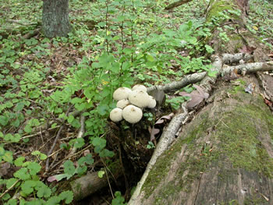
Figure 1. A cluster of Lycoperdon perlatum on decaying
wood. Forest Lake Photo © Gary Emberger
Dimensions: Fruit bodies have an average width of 4.5 cm and an average height of 6.0 cm tall.
Description: This puffball species is round to pear usually with an elongated, stalk-like base. When young it is white and covered with conical white spines with shorter spines and granules between them. With maturity the longer conical spines are usually broken off leaving a pattern of pits or net-like scars on an aging yellow-brown surface. The spore-producing internal tissue (gleba) is moist, white at first, turning olive-brown, and powdery when mature.
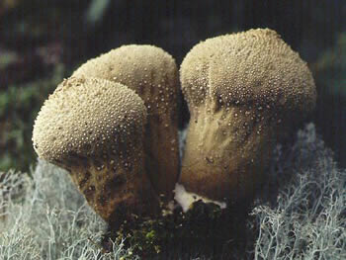
Figure 2: Lycoperdon perlatum turns a buff or yellow-
brown color with age. Photo © Larry Grand
A pore-like mouth known as the ostiole forms at the apex at maturity allowing spores to be released when raindrops or twigs strikes it disturbing the outer case.
. 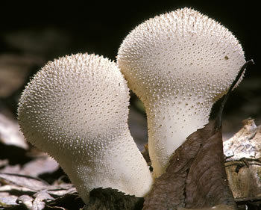
Figure 3: Side view of Devil's snuffbox shows the
sterile stalk-like base supporting the upper spore-producing
covered by conical spines. Photo © Fred Habegger
Edibility: Edible. However, this species is edible only when the internal spore tissue (gleba) is completely white and uniform in appearance. One must be careful not to confuse puffballs with young stages of Amanita species. A longitudinal section of a young Amanita will reveal some tissue differentiation into gills. Gills never occur in puffballs.

References
Kavanagh, K. (. (2017). Fungi: biology and applications. John Wiley & Sons.
Stamets, P. (2008). 6 ways mushrooms can save the world. TED http://www.ted.com/talks/paul_stamets_on_6_ways_mushrooms_can_save_the_world

